AGRICULTURE

Summarise the following articles by listing the key words and phrases.

IRRIGATION:
Once the Ancient Egyptians learned the techniques of irrigation, they were aided by natural features which made the task of farming easier and the yield from crops higher.
The shape of the valley was a gentle hollow – higher at the sides and lower at the middle- allowing the annual flood to cover most of the cultivated areas of the Nile Valley. It meant that during years in which the flood reached its normal level, high yields were possible with the deposition of a fresh layer of silt all over the valley floor. The flood also gave the soil the thorough soaking it needed to allow the seed grain to germinate.
Problems of salination (in which soil is spoilt by salt) did not ruin Egyptian fields. The slope of the river meant that water did not lie still above and below the soil. As the water was continually on the move, it washed the salt downriver with it. This moving water meant that water channels did not become clogged with silt.
__________________________________________________________________________________________________________________________________________________________________________________________________________________________________________________________________________________________________________________________________________________________________________________________________________________________________________________________________________________________________________________________________________________________________________________________________________________________________________________________________________________________

________________________________________________________________________________________________________________________________________________________________________________________________________________________________________________________________________________________________________________________________________________________________________________________________________________________________________________________________________________________________________________________________________________________________________________________________________________________________________________________________________________________________________________________________________________________________________________________________________________________________________________________________________________________________________________________

Ancient Egyptians used basin irrigation to water their crops. It was the most efficient and suitable method for the environment of the Nile Valley. The valley floor was divided by huge embankments into basins up to 16000 hectares in area. During the flood, water was diverted into a canal and led down river into the basin where smaller distributary canals spread the water evenly throughout the basin.
When the soil became saturated with water, the surplus water was drained into the next basin or returned to the river.

_________________________________________________________________________________________________________________________________________________________________________________________________________________________________________________________________________________________________________________________________________________________________________________________________________________________________________________________________________________________________
The importance of irrigation to farming in Ancient Egypt is shown by the title given to provincial governors – adjmer or canal digger. The central government had a department of water administration. One of the duties of this department was to measure the height of the flood. Nilometres or “flood metres” was at the House of Inundation on the island of Roda of Memphis.

Orchards and vegetable gardens needed year-round irrigation. Before the shaduf was invented water had to be carried by buckets from the river up to irrigation channels by hand. The shaduf was a pole resting on a pivot with a large bucket on one end and a heavy stone on the other end. This allowed water to be lifted with less effort into irrigation channels – one man could lift 2 500 litres or more of water a day.

__________________________________________________________________________________________________________________________________________________________________________________________________________________________________________________________________________________________________________________________________________________________________________________

Answer the following questions on a separate sheet:
- Using your key words and phrases write a summary of this article using no more than 100 words.
- The tool is the diagram below is a shaduf. Explain how it works.
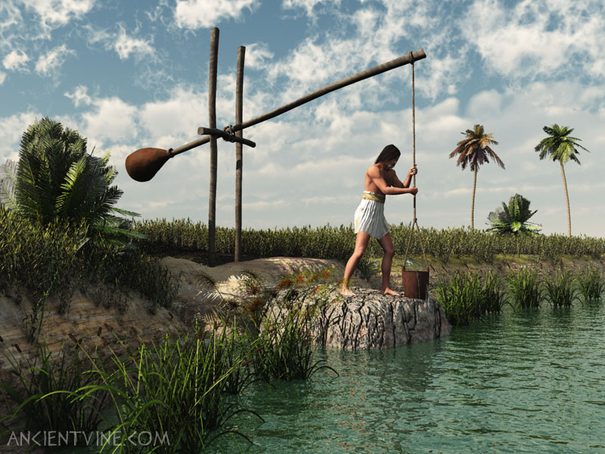
http://www.google.com.au/imgres?q=shaduf&um=1&sa=N&hl=en&biw=1280&bih=843&tbm=isch&tbnid=gz_z6LlK2mgS9M:&imgrefurl=http://www.ancientvine.com/shaduf.html&docid=kaYMu1aKU16ZyM&imgurl=http://www.ancientvine.com/avimage/shaduf1.jpg&w=800&h=600&ei=VtqJUZCnI6e9iAfa-IGACQ&zoom=1&iact=hc&vpx=2&vpy=62&dur=311&hovh=194&hovw=259&tx=96&ty=108&page=1&tbnh=131&tbnw=165&start=0&ndsp=37&ved=1t:429,r:0,s:0,i:161

